# Small Enterprise Middle East

# &

# Events

# Business Plan

**By**

**Dojo Jose**

**+97152-9049801 / 050-5517689**

**Email:** [**dojo@smallenterpriseindia.com**](mailto:dojo@smallenterpriseindia.com)

**Table of Contents Page**

Executive Summary 3

The Business 5

Regulations and permits 6

Product or Service 6

**Unique features or proprietary aspects of Product** **8**

Vendors 9

The Market 9

Competition & Risk 24

Management Team 28

**Management Profile…………………………………………………………………………………………………………28**

Financial Plan 33

EXIT Plan 34

Executive Summary

**About Small Enterprise Middle East & Events Business in UAE**

The UAE publishing industry is cluttered with various titles ranging from entertainment, Family, Business, technology, Kids and so on.

Aspire Media Pvt Ltd, based in Bangalore, India, is the publisher for Small Enterprise India.com portal. Launched on 7 July 2010, Smallenterpriseindia.com’ is a functional professional training cockpit for the entrepreneurs which expands the comprehensive audience and complement the complete package. The portal is a repository of verified reliable professional information, providing support through useful working tools as well as online campaigns, seminars, road shows and live trainings on trend issues and important reforms. We focus on in-depth coverage of the Indian small and medium businesses, success stories, case studies etc, enabling the target audience to communicate, collaborate and understand the industry, market as well as opportunities available locally and globally in a better way.

We plan to publish the print, digital and online version of Small Enterprise Middle East which will be directed at the SME community. An English version initially to launch and within 1 year to publish an Arabic edition. As in any developing countries, UAE, GCC and ME region has a strong 90% contribution to its economy by SMBs. The small and medium enterprises (SME) sector in the Middle East plays a vital role in the growth of the region’s economy.

Despite its commendable contribution to the Nation's economy, SMEs faces a number of problems - absence of adequate and timely banking finance, limited capital and knowledge, non-availability of suitable technology, low production capacity, ineffective marketing strategy, identification of new markets, constraints on modernisation and expansions, non-availability of highly skilled labour at affordable cost, follow up with various government agencies to resolve problems etc.

**1.1 Objectives**

1. The initial objectives are as follows:
2. To raise seed capital of AED 3 Million to ensure publication by month two and to establish a cash reserve to market subscriptions.
3. To have 2000 subscribers by the end of year one through direct sampling and marketing.
4. To have an additional 2000 sale copies by the end of year one through organizational sales.
5. To publish 84 page issues initially with press runs of 2000 copies.
6. To go to 92 pages by issue number seven and increase press runs to 3000 copies.
7. Increase average ad page cost from US$ 1500 to US$ 2000 by the end of the first year.
8. To sell an average of 8 ad pages per issue throughout year one.
9. Organise 2 Events and one small business makeover campaign by end of first year.
10. Start a small business member networking club in Dubai, UAE by end of first year.

**1.2 Mission**

"Small Enterprise" magazine is for SMEs, aspiring entrepreneurs and startups. The magazine has a commitment to be a platform to profile entrepreneurs who are have the vision in the marketplace and who can both encourage and provide role models to other men and women. Aspire Media, through its magazine, and editorial content, will be a vessel to inform SMEs about streamlining their everyday business, help startups and aspiring entrepreneurs and will encourage interaction among small business people. Our mission is to promote entrepreneurship through all Emirates in UAE, GCC and eventually Middle East countries.

**1.3 Keys to Success**

The keys to success are:

1. Attaining targeted circulation levels – Print, Digital and online.
2. Start Initially an English edition and later with an Arabic Edition of the portal and magazine (Print & Digital)
3. Controlling costs while spending the maximum on subscription marketing in year one.
4. Carefully monitoring response rates of all media executions.
5. Follow-on marketing of the magazine and events in the first year.
6. Attaining targeted advertising sales revenues.
7. Having quality editorial content in each issue.
8. Making all production and distribution dates in a timely fashion for each issue.
9. Big focus on B2B Events

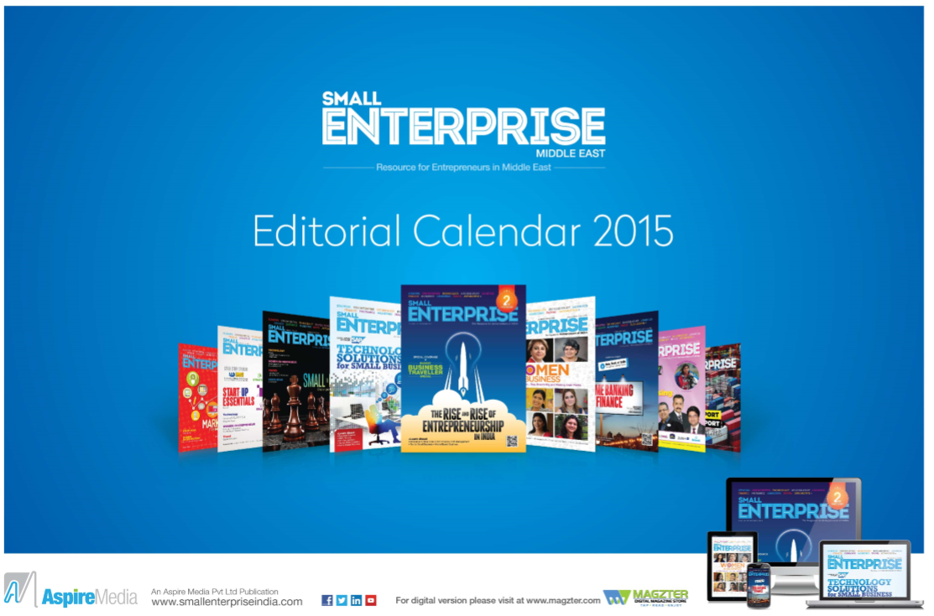

THE BUSINESS

Description of the Business

***Small Enterprise ME - the Middle East small business portal with a difference will focus on “self-help for entrepreneurs and start-ups”***

We focus on in-depth coverage of the Middle East small and medium businesses, success stories, case studies etc., enabling the target audience to communicate, collaborate and understand the industry, market as well as opportunities available locally and globally in a better way.

We plan to conduct multi city roadshows to help the SMB community in UAE and GCC - a road show named “SME Learning Series” ( [www.smelearningseries.com](http://www.smelearningseries.com) ). Small Enterprise ME.com portal will have a weekly newsletter blast to its subscribers, helping them keep abreast of latest info, case studies, success stories that may help them streamline their existing business as well as boosting entrepreneurship across the country.

**Target Audience**

* Existing entrepreneurs
* Aspiring entrepreneurs
* B-schools / Engg / IT Students
* College Dropouts
* CEOs, CFOs of SMEs & Start Ups
* Private Equity Companies, Venture Capitalists, Bankers
* Family Owned Business
* Business Leaders, Business Gurus, Think Tanks and Educational institutions

Regulations and Permits

Will need to seek a Publishing license from Media City and office for a minimum 900 Sq ft that can accommodate 6-8 staff in the beginning.

Products or Service

Small Enterprise ME.com is the one-point reference repository which provides a platform that enhances the visibility of SMEs and aspiring entrepreneurs in Middle East’s economic growth story. The portal preserves the lineage of providing information and knowledge that facilitate informed business decisions.

**Products**

**1. Print** – Small Enterprise - Monthly Magazine and supplements

**2. Online** – www.smallenterprisieME.com - Web banners, EDM, Newsletters

**3. SME Learning Series** – www.smelearningseries.com – SME Events

4. **StartUp Hunt –** A platform for aspiring entrepreneurs to find investors

**5. SMB Makeover Campaign** – A campaign that will be run through all media platform within the

company and partners

**6. Franchise –** Small Enterprise title will be a licensed publication for the emerging markets

**7. Small Enterprise Business Network (SEBN)–** This will a membership club for SMEs to get more

referrals for their business. Each city will have separate SEBN club headed by a local representative.

8. **SEI TV** – A dedicated Video section that showcases the events, startup interviews and expert view.

**Service**

***1.*** *Expert advice from our Advisory board members*

*2. Updated info on How to Start Up*

*3. How to Streamline existing Small business by using info through the portals various sections like*

*Technology, Knowledge Centre, Case Studies, Success stories, Finance, HR, Sales & Marketing.*

*4. A Q & A section called “Ask Guru”*, for SMEs and Entrepreneurs to raise their query on any subject

related to start ups or opportunities, finance, management …all answered by our Expert Advisory

members.

5. Survey Poll feedback on various aspects related to Small Business

6. Special Section to boost Women Entrepreneurs

7. A special section to provide more info about budget travel for SMEs called “SME Traveler”.

8. Online book store related to small business

9. Special section for business opportunities – local & international

10. Franchise options

10. Resource centre – a special section on various Govt initiatives for SMEs, tenders and information

about Free Zones.

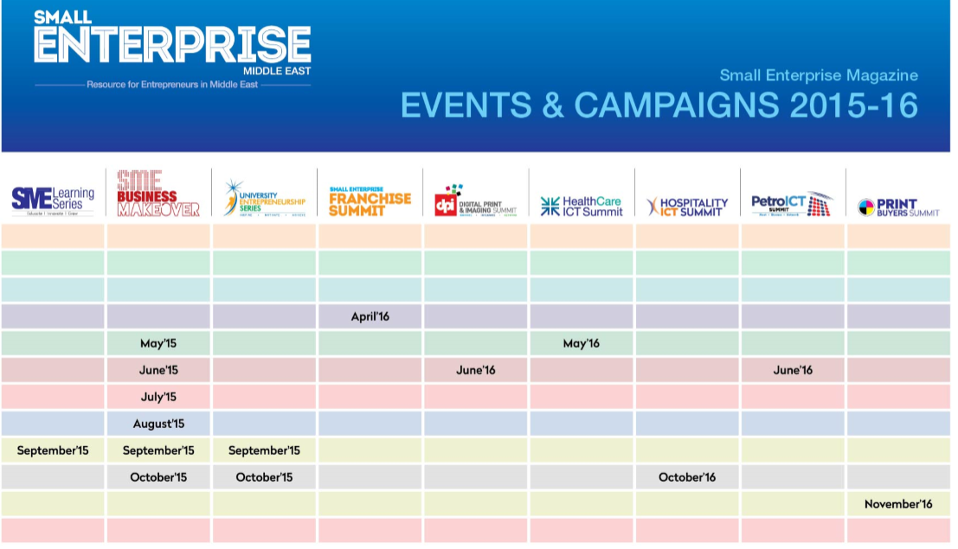

Unique features or proprietary aspects of Product

**What Differentiates Small Enterprise Middle East**

There are many business publications in Middle East. Business, technology, Channel magazines, retail, Life Style and Fashion. All of these business titles focus on macro business trends, news and opportunities in UAE, GCC and Middle East. Very few publications on Small Business and mostly all of them remain to print editions.

* **Online :** Small Enterprise ME looks at the micro level Small business opportunities, trends and opportunities. In depth analysis of SME success stories, case studies. Focus more on startups, the objections they have faced on their journey. Practical Advice through our “Ask Guru” online expert advisory panel. Start Ups are taking a big leap and are fast growing. Small Enterprise ME expose these brave hearts and kindle their entrepreneurial spirit by conducting SME Learning Series road shows. Our expert panel provides inspirational business tools and practical advice.
* **Print Version:** A monthly magazine (print version) in English, to reach large audience across the country and eventually publish the magazine in 3-4 leading national languages. The magazines will be sold through book stands and boost annual subscription. The major revenue source apart from subscription and stand sales would be from advertisements through the print, online and SME Events.
* **SBN Group:** The SME Business Network is a proposed offshoot small business network group.. We offer members the opportunity to share ideas, contacts and most importantly, business referrals to generate instant business within the group members.
* **SME Events – “SME Learning Series” Road Show:** SME Events are specially created to boost entrepreneurship and help SMEs streamline their existing business across the nation. The event will attract a SME gathering of 120+ in each locations. The invitees will be small and medium business owners (such as Managing Directors, Proprietors, Directors, Managing Partners, Partners, IT Managers,) who own small and medium companies from industrial areas. There will be a great element of learning for SMEs from these events as they could take home many advanced and new information and could possibly adapt to their existing business. The events are targeted at students and Start Ups as well. **Start-up Hunt** will be business start-up pitch for aspiring entrepreneurs looking for funding from VCs and angel investors. **Small Business makeover** Campaign is an innovative business makeover for the lucky start-ups.
* **Franchise opportunity:** This will help Startups to find new business ideas by getting to a franchise deal. With their ready to start business templates, startups can have easy access to start their new business. Small Enterprise ME will have Franchise sections that can benefit the SMEs.

Vendors

Small Enterprise ME would be platform for any vendors targeting SMEs and aspiring entrepreneurs. All medias including the Print, online, campaigns and Events will attract vendors who wish to reach SMEs and address their needs for business solution.

|  |  |  |  |  |
| --- | --- | --- | --- | --- |
| **Technology** | **Banking & Finance** | **Free Zones** | **Telecoms** | **Automobiles** |
| HP | NBAD | SEZ | Etisalat | Honda |
| Samsung | HSBC | Hamriyah FZ (Shj, UAE) | DU | Volvo |
| Cisco | ADCB | Fujairah FZ, UAE | Mobily | Ford |
| SalesForce.com | Abraaj Capital | Smart City, Kochi India | Oman Tel | Toyota |
| Sony | Standard Chartered | Smart City, Malta | Huawei | Nissan |
| LG | Mashreq Bank | Canada Business | Qualcomm | Hyundai |
| Philips | Citibank | Qatar | Idea | Kia |
| MSI | Shuaa Capital | RAKIA FZ | Zain |  |
| ASUS |  | AJMAN FZ |  |  |
| Motorola |  | Sharjah FZ |  |  |
| Canon |  | Dubai FZ |  |  |
| Xerox | Other Financial Institutions |  |  |  |
| Brother |  | **OTHERS** |  |  |
| OKI | **Logistics:** | **Budget Hotels** |  |  |
| Fujitsu Siemens | DHL | **Budget Airlines** |  |  |
| DELL | **FEDEX** | **Travel Agents** |  |  |
| Microsoft | UPS | **Head Hunters** |  |  |
| IBM | ARAMEX | **Insurance Companies** |  |  |
| HTC |  | **Consultants** |  |  |
| Lenovo |  | **Business Centers** |  |  |
| AMD |  | **Property Developers** |  |  |
| Intel |  | **Universities** |  |  |
| EMC |  | **Business Schools** |  |  |
| SAP |  |  |  |  |

THE MARKET

The overall share of SMEs in the Middle East-North Africa region is estimated at 71 per cent of employment but only 28 per cent of GDP. Citing Bahrain, the GDP share of SMEs is 28 per cent while they are responsible for 73 per cent of all private sector jobs.

In Dubai, SMEs are estimated to make up 95 per cent of the total number of enterprises, 42 per cent of the workforce, and 40 per cent of GDP.

Saudi Arabia’s SMEs are responsible for approximately 40 per cent of jobs in the country, although some estimates put the figure even lower, NCB said, adding that their GDP contribution is estimated at 28-33 per cent.

In Bahrain, nationals account for only 14 per cent of SME employment, while the Saudi private sector as a whole is some 90 per cent.

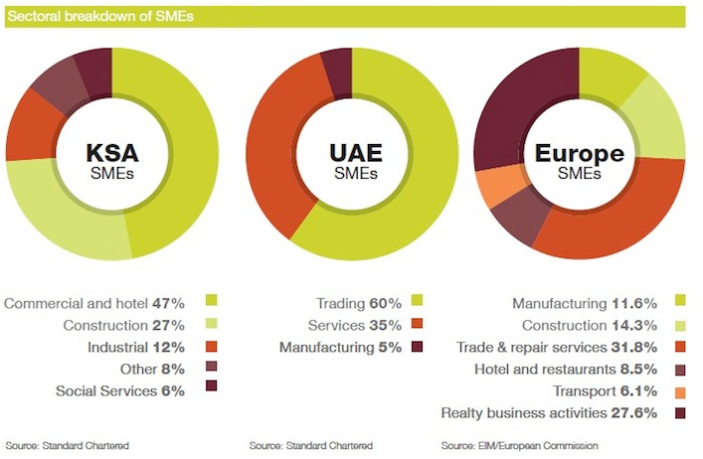

Despite its commendable contribution to the region’s economy, SMEs faces a number of problems - absence of adequate and timely banking finance, limited capital and knowledge, non-availability of suitable technology, low production capacity, ineffective marketing strategy, identification of new markets, constraints on modernisation & expansions, non-availability of highly skilled labour at affordable cost, follow up with various government agencies to resolve problems etc.

Market Definition

The SME definition serves as a ‘common language’ that leads to convergence of multiple

stakeholders engaged in various SME development roles and activities. It enables efficient coordination

and collaboration amongst these stakeholders. Additionally, it serves as a baseline

and framework for implementing multiple initiatives directed towards the development of SMEs.

The below figure illustrates the SME definition for Dubai classified according to the sectors and size of

businesses.

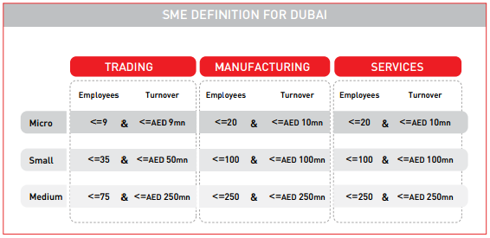

**Within Trading:**

• A micro business is any enterprise with less than or equal to 9 employees AND a turnover of

less than or equal to AED 9 million.

• A small business is any enterprise with less than or equal to 35 employees AND turnover of

less than or equal to AED 50 million.

• A medium business is any enterprise with less than or equal to 75 employees AND turnover

of less than or equal to AED 250 million.

• Any enterprise with greater than 75 employees OR turnover greater than 250 million will be

considered ‘large’.

**Within Manufacturing:**

• A micro business is any enterprise with less than or equal to 20 employees AND a turnover

of less than or equal to AED 10 million.

• A small business is any enterprise with less than or equal to 100 employees AND turnover of

less than or equal to AED 100 million.

• A medium business is any enterprise with less than or equal to 250 employees AND turnover

of less than or equal to AED 250 million.

• Any enterprise with greater than 250 employees OR turnover greater than 250 million will

be considered ‘large’.

**Within Services:**

• A micro business is any enterprise with less than or equal to 20 employees AND a turnover

of less than or equal to AED 3 million.

• A small business is any enterprise with less than or equal to 100 employees AND turnover of

less than or equal to AED 25 million.

• A medium business is any enterprise with less than or equal to 250 employees AND turnover

of less than or equal to AED 150 million.

• Any enterprise with greater than 250 employees OR turnover greater than 150 million will

be considered ‘large’.

Market Research

The print media, which is fast losing circulation and advertising revenue in the West, continues to maintain its sway in the oil-rich GCC region.

In 2012, Advertising revenues in the region grew five percent year-on-year to a staggering $4.8bn (QR17.47bn), with the UAE and Saudi Arabia having the largest shares — 33 and 30 percent, respectively — in advertising spending. Kuwait trailed with a 20 percent share and the remaining three GCC states — Qatar, Oman and Bahrain — together accounted for 17 percent share of the total.

Kuwait Financial Centre (Markaz) report said yesterday companies in the region have begun to increase their media spending budgets as regional economies seem to come out of their hiatus.

The landscape of the regional media industry is changing at a rapid pace as a result of technological advancements and changing consumer habits.

Digital media is growing in influence and effectiveness, the report said. The digital media has a share of 18 percent in global advertising spending and the percentage is set to inch up to 20 in 2014.

The print media is still going strong in the GCC with a high 71 percent share in the overall advertising spending. The digital media is still in its infancy but growing at a brisk pace. In the GCC, print media is still considered more trustworthy and, thus, grew at an average of 3.5 percent annually between 2007 and 2011*. (The Peninsula, Qatar).*

The media and advertising industry faced many challenges and recorded declining revenues with the onset of financial and economic crisis in the later part of 2008.  “However, the GCC region was not as badly hurt by the economic downturn as the Western economies,” said the report.

Markaz noted that the media industry landscape is also changing rapidly as a consequence of technological advancements and changing consumers’ habits. “The digital media is growing in influence and effectiveness. Presently, the digital media captures 18 per cent of global media share of ad spending, which is expected to grow to 20 per cent by 2014.”

According to a report carried out by OOXmonitor, a web-based service that provides advertising monitoring in the Middle East, digital ad spend grew by 12.6 per cent in the UAE compared to 5.3 per cent in Saudi Arabia in 2012. The UAE accounts for 47.1 per cent of GCC online ad spend.

Print media is still going strong with 71 per cent share of overall ad-spending, the digital media “is still in its infancy” in the region but growing at a brisk pace. Social networking and use of social media sites have been on the rise in the GCC.

**UAE**

**Population : 2013 estimate 9,346,129**

**Language(s) : Arabic (official), English commonly used as second language**

**Literacy rate : 77.9%**

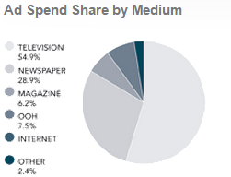 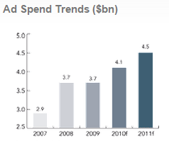

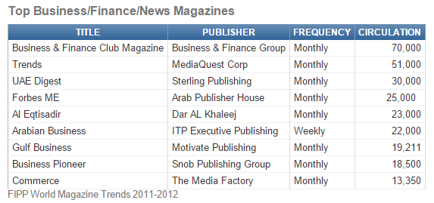

The UAE advertising industry accounted for a 33 per cent share of the GCC’s total ad spend estimated at $4.8 billion in 2012 to remain number one, as the print media continued its dominance with a 71 per cent share of the overall market.

Contrary to global trends, newspaper circulation clocked the highest worldwide growth rate of 4.8 per cent in the Middle East and grew by 3.5 per cent in Asia, the Kuwait Financial Centre (Markaz) said in its GCC Media report.

Saudi Arabia has the second largest share of ad spending with 30 per cent, followed by Kuwait with 20 per cent as the total ad spend in the region grew by five per cent in 2012, Markaz revealed in its GCC Media report.

The feel-good factor continues to fuel the UAE’s advertising industry, with an estimated $398 million (Dh1.46 billion) being spent in the first three months of the year against $381 million same time last year. And it looks as if the upbeat sentiment will run for quite a while yet.

A clear pattern is starting to show up since early 2013 — if the first-half of last year saw steady increases in spending, there was a sharp spike in the second-half as build-up towards the confirmation of Dubai as the host city for World Expo 2020 in late November. December sparked a celebratory round of advertising highs as marketers and the local ad industry got the confirmation that the upturn was well and truly on.

Traditional media continues to hold its own in the UAE’s ad mix; newspapers pulled in $227 million for a steady 57 per cent share, while magazines accounted for $58 million (15 per cent share of the overall). Television commercials fetched $31 million in the first quarter, representing 8 per cent of the total. The share of outdoor media, at $59 million, was also put at 15 per cent. (The Parc numbers do not track digital media spend.) – *(Gulf News, May 6, 2014)*

**Saudi Arabia**

**Population : 2013 estimate 29,994,272**

**Language(s) : Arabic (official), English commonly used as second language**

**Literacy rate : 86.8%**

**Print**

Saudi Arabia has a total of 15 daily newspapers with a total daily circulation of approximate 1.9mil.

As with the decline of circulation and advertising revenues internationally, Saudi Arabian Print companies have also been experiencing this trend but to a lesser extent.

List of newspapers in Saudi Arabia according to region:

* Dammam: Al-Yaum, Arab News (English)
* Jeddah: Okaz, Al-Bilad (Oldest Arabic Daily), Al-Hayat, Al-Madina Al-Awsat, Al-Nadwah Al-Awsat, Al-Riyadeyyah, Arab News (English), Asharq Al-Awsat, Saudi Gazette (English) and Shams
* Riyadh: Al-Jazira, Al-Riyadh, Al-Watan, Arab News (English),
* Mecca: Shams
* Okaz (250,000 circulations) and Al-Hayat (270,000) are the most popular newspapers in Saudi.
* Nonetheless, structural changes to this industry can be seen in the shifting of Al Majalla from print to pure online editions in part to explore a new Arab journalism style and also in response to the print crisis.
* However, while other markets are struggling to maintain print circulation, Saudi Arabia expects circulation of daily newspapers to grow by 2.3% in the next 5 years.
* Magazines also remain a popular choice of print media in Saudi with the top three being Sayidati, Zahrat Al Khaleej and Laha, which are all pan-Arab women’s magazines.

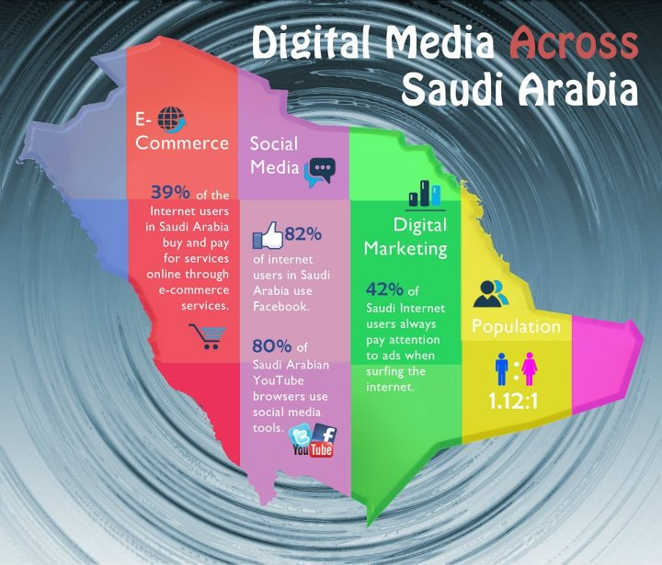

Saudi Arabia has a fast-growing internet population which of which highly adaptive and mobile youth are making up an increasing proportion. Online commercial efforts in Saudi Arabia, however, require a highly adapted approach given the unique cultural landscape. Growth of digital media in Saudi Arabia also depends on development of support infrastructure and a need for government community engagement through integrated channels.



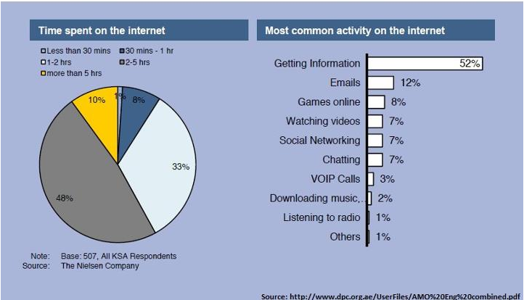

**DOHA, Qatar**

**Population : 2014 estimate 2,155,446**

**Language(s) : Arabic (official), English commonly used as second language**

**Literacy rate : 79.0%**

Over the last several years Qatar has experienced a steady economic growth driven mainly by the production and export of liquefied natural gas (LNG) and crude oil. Furthermore, in preparation to host the FIFA 2022 World Cup event, government has ramped up spending on infrastructure projects –such as roads network upgrade, new airport, schools, hotels, residential buildings, shopping malls and more.

Solid economic outlook and a very high GDP Per Capita have made Qatar an attractive market for regional and international businesses to capitalise on. Qatar’s population has had a substantial growth averaging 3% in the past three years. Nationals and professional expats are generally tech savvy and they connect online frequently to communicate and shop for services and goods.

Al Arab newspaper, which began publishing in 1972, was the first political daily, and Al Ahd press was the first political weekly. In 2002, in addition to the government-owned newspapers, there were seven privately owned publications. The privately owned publications were Al-Raya, Al-Sharq, Al-Watan , Arabic language newspapers; The Gulf Times and The Peninsula , English language newspapers; and Qatar Al-Khair and Al-Doha Lil-Jamiah , magazines publishing news, including politics, business, social, finance, health, art and entertainment. For many years, the Qatari government provided a financial support for local newspapers and press. However, this was stopped in 1995, the same year that media censorship was lifted. This left the press essentially free from government interference and many national and international newspapers an magazines started to appear in the Qatari market such as the New York Times, Time magazine, Financial Times and Alquds Alarabi .

**Qatar Internet Growth and Population Statistics:**

|  |  |  |  |
| --- | --- | --- | --- |
| **YEAR** | **Users** | **Population** | **% Pop.** |
| 2000 | 30,000 | 624,422 | 3.8 % |
| 2002 | 126,000 | 768,464 | 16.4 % |
| 2005 | 165,000 | 795,585 | 20.7 % |
| 2009 | 436,000 | 833,285 | 52.3 % |
| 2012 | 1,682,271 | 1,951,591 | 86.2 % |

**Bharain**

**Population : 2014 estimate 1,343,000**

**Language(s) : Arabic (official), English commonly used as second language**

**Literacy rate : 94.6%**

Advertising spend in Bahrain grew five per cent last year to $94 million when compared with the previous year's figure of $90 million, and the sector was set for higher growth in 2014 and regain its earlier growth rate, said an industry expert.

According to the Pan Arab Studies and Research Company (PARC)'s latest annual report, the figures confirm earlier forecasts that Bahrain's advertising spend for last year would not exceed $100 million, reported the Gulf Daily News (GDN).

In 2013, the print media had a share of 86 per cent, which included 71 per cent for daily newspapers and 15 per cent for magazines, followed by TV commercials with a share of 8 per cent and outdoor advertising with a share of 5 per cent.

Daily newspapers took 66 per cent of revenue at $30 million while magazine advertising at 18 per cent was $8 million and television was $5 million with 11 per cent of the market.

**Oman**

**Population : 2014 estimate 4,055,418**

**Language(s) : Omani Arabic (official), English commonly used as second language**

**Literacy rate : 86.9%**

Oman, advertising spend increased by 9pc to reach $356 million in 2013 against $271m in 2012.

Market Segment

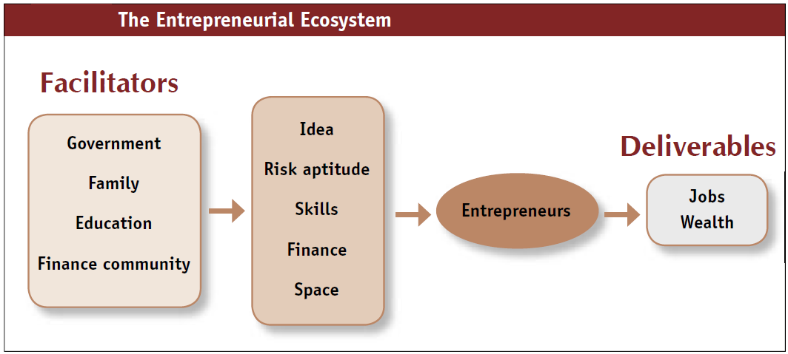

Market segmentation is the process of dividing an entire market up into different customer segments. Targeting or target marketing then entails deciding which potential customer segments the company will focus on. Marketing segmentation always comes before targeting, which helps a company be more selective about who they are marketing their products to. Marketing segmentation and targeting are equally important for ensuring the overall success of a company.

**Significance**

Marketing segmentation and targeting are particular important for finding customers that are the best match for a business products and services. It is not feasible to go after all customers, because customers have different wants, needs and tastes. Some customers want to be style leaders. They will always buy certain styles and usually pay a high price for them. Other customers are bargain shoppers. They try to find the lowest price. Obviously, a company would have difficulty targeting both of these market segments simultaneously with one type of product. For example, a company with premium products would not appeal to bargain shoppers.

**Identification**

The process of marketing segmentation and targeting are necessary to identify and target certain demographic groups. Customer demographics can include gender, age, income, household size, geographic area and even various ethnic groups. One or more of these demographic segments will be more likely to purchase a company&#039;s products or services, while other demographic segments may be more suitable for competitive products or services. Hypothetically, a certain new radio station may discover that their music appeals more to 34-to-54-year-old women who earn over $50,000 per year. The station would then target these women in their marketing efforts.

**Types**

Marketing segmentation and targeting can be used for both consumer and business customers. Besides demographics, other ways to segment consumers is by different psychographic or behavioristic characteristics, such as their interest and usage rate, respectively, according to the article “ Market Segmentation” at Net MBA, a well-respected online business reference site. Business customers are usually segmented by company type and size. For example, a small food distributor may likely target small or mid-sized restaurants, hospitals and nursing homes.

**Function**

Marketing segmentation can be a lengthy process. It is important for the company to know exactly which segments represent the most potential sales for its business. After a company identifies all possible market segments, it can start targeting these customer segments with direct mail, magazine, radio, television, and even Internet marketing. Targeting specific customers entails creating the right advertising message with the right media. For example, an ad for an expensive perfume would be well-suited for one or more premium style magazines that fill grocery store magazine racks.

**Considerations**

Companies can perform marketing segmentation and targeting by first conducting some marketing research. The company will need to include demographic types of questions, so it can later determine which demographic groups comprise the majority of their customer base. Companies that use marketing segmentation and targeting properly can usually expect great sales and profits, according to Evan Carmichael&#039;s site, a top resource for small business strategies.

**Demographics**

Demographic market segmentation is one of the most common approaches to segmenting markets. With this strategy, a company simply divides the larger market into groups based on several defined traits. Age, race, gender, marital status, occupation, education and income are among the commonly considered demographics segmentation traits.

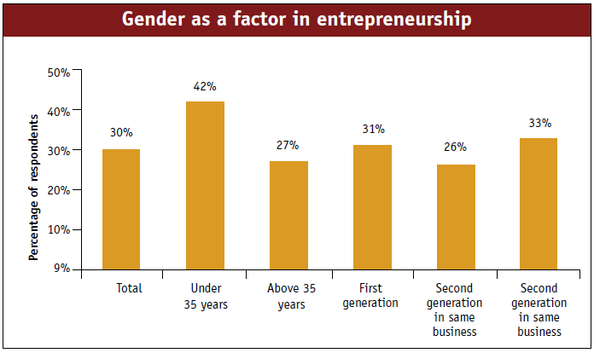

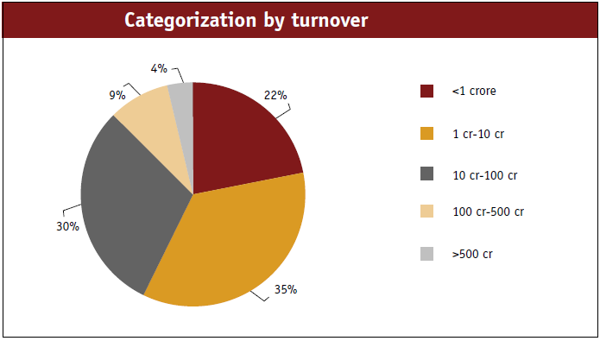

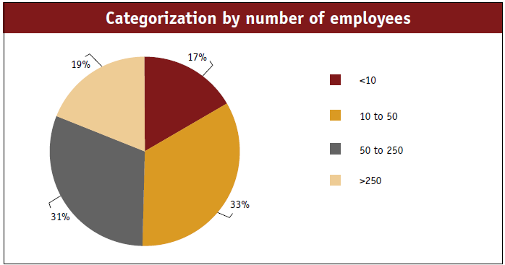

**Geographic**

Geographic segmentation is used by companies that sell products or service specific to a certain community, state, region, country or group of countries. Local businesses usually get no benefit in paying for national or international advertising. Companies that operate nationally can often save by delivering the same marketing messages to a national audience through one television, radio, magazine or newspaper ad. Global businesses typically decide whether to maintain a universal message or tailor messages to each country's marketplace.

**Psychographics**

Psychographics or lifestyle segmentation has become increasingly common as companies look to identify consumers based on interests and activities in lieu of demographics. As an example of this strategy's benefits, consider the lifestyle of an outdoor adventurer. Camping enthusiasts, for instance, typically have few consistent demographic traits. Campers are a diverse group. Thus, marketers would likely target a segment of outdoor hobbyists or campers for new camping equipment through outdoor programs or magazines.

**Behavioral**

Behavioral segmentation is based on user behaviors, including patterns of use, price sensitivity, brand loyalty and benefits sought. A company may have customers with a similar demographic makeup but distinct behavioral tendencies. Some may use the product daily, while others use it weekly or monthly. Higher-income earners may have more interest in higher-quality models versus low-cost models. This may prompt the provider to target higher-end products and services to one group and more value-oriented offerings to lower-income or budget-conscious customers.

**Business Segmentation**

Segmenting for business customers often has overlap but commonly includes geographic, customer type and behavior-based strategies. Geographic business segmentation is similar to that with consumer segmenting. Customer type segmenting may include business size or the nature of the business. Banks, for instance, often have different products for small versus large businesses. Behavioral segmenting is based on repeat or loyal customers versus one-time users.

Marketing

**Introduction**

Print Media in India is more than a century old and a well-established industry. The print industry mainly comprises of newspaper and magazine publishing. Book / magazine publishing is smaller but significant in terms of revenue. Even though it's a mature industry, new magazines are being launched every year. India has been one of the fastest growing world economies since the past three years. Robust consumption and rising income levels have helped the growth of print media. New titles that focus on niche topics continue to launch in the market. The revenue sources for a magazine are subscription, single copy sales and advertisement. ***Approximately 73 percent of revenue comes from advertising and 27 percent from circulation.***

**Challenging Times**

The magazine industry is going through a tough phase worldwide. Newspapers have added supplements to their main issue and infringed on the content covered by magazines earlier. Television channels have launched in different genres that didn't exist a few years back. And with the increased penetration and adoption of the Internet in the country, more people are now consuming news and stories on different topics on the web and mobile. There is still a demand for high quality print content and magazines need to deliver on that need to avoid losing market share to other mediums. In addition, they also need to explore and distribute their content on the web and mobile platforms to give choice to their subscribers to consume content from anywhere and at any time.

***Distribution through News Stands (retail)***

<http://arcgate.com/blog/2010/09/29/indian-magazine-market-overview/>

* Print magazines in general have come down. Because, newsstand sales are down so also are subscriptions.
  + Not surprising, as this is a trend in line with international markets.
  + However, to meet  this challenge, we need to get strong in distribution-having our own person in major markets to focus on merchandising.
* Newsstand sales could be down due to a plethora of B2C and B2B magazines in the market.
* Major Outlets in GCC markets
* Petrol Stations
* Airport Duty Free outlets
* Business Hotels
* Airlines

It depends on the content. Somehow, magazines like Entrepreneur are like any other business magazine and not much SME focus.

**Subscription**: In India with increasing literacy and entrepreneurship, the way forward for us is to widen our distribution and innovative methods to push subscriptions [not just gifts] – Example : Subsidised Subscription through Universities, Colleges, B-Schools with more value add products like a Free course on Entrepreneurship or management, marketing, finance etc.

**Online** magazine subscription.

**Mobile Phone:** iPad, Andriod, iPhone, Blacberry applications and tablets.

**Selective Distribution**: Special sponsored copies are distributed in airplanes and hotels.

**Sales Tactics**

Advertiments, Online ad revenue generation, Magazine Subscriptions through various promotions, Events.

**Pricing**

Competitor magazines are priced at Rs 100 – 120 on stand. We shall start from Rs 50 and later increase from year 2 onwards.

**Packaging**

The magazine will be designed to international standards. The cover design should attract eyeballs on stands. Subscription will have a special offer pricing and a value for money give away.

POSITION

Every magazine needs to be someplace in the minds of buyers of media. Buyers need an idea around which they can build and eventually sell their own rationale for buying your magazine. We call that idea "position" and the process of getting there "positioning."

Positioning actually comes in two flavors. One is emotional positioning that creates permission to buy - Rolling Stone's Perception/Reality being a case in point. Or, in the best of all possible worlds, one that kindles a warm receptivity - for example, Sport's Illustrated's "Get the feeling" positioning line.

The second aspect of positioning focuses on placing a magazine in a media context that allows it to be bought along with others. SI's immortal "The third newsweekly" is the classic example of that. The line executed a brilliant two-step: It intruded the magazine into a category where it had not previously been considered and, simultaneously, placed SI in an advantageous position within the category, ahead of U.S. News. All of which illustrates the positioning principle that you have to join 'em before you can lick 'em. A magazine must establish its similarities to others in a competitive set before it can sell its differences.

COMPETITION

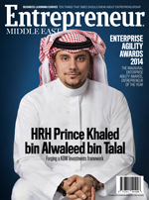 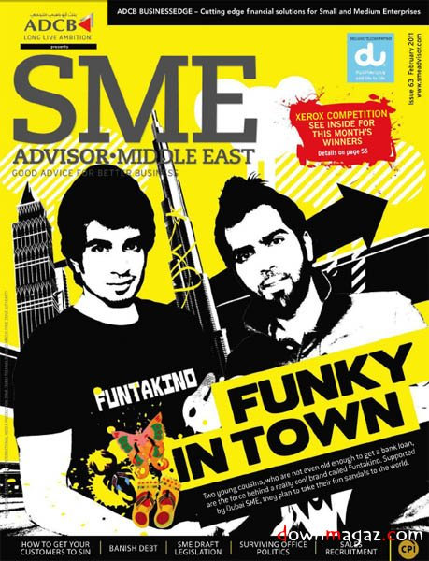

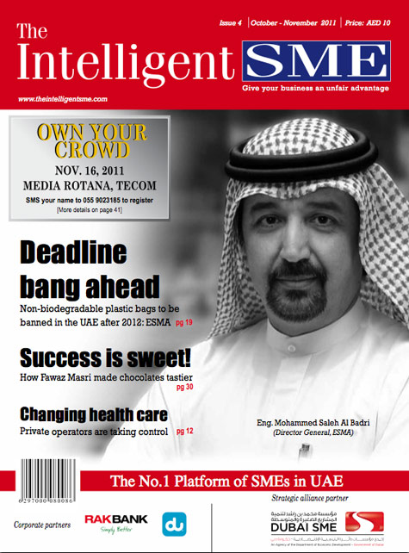 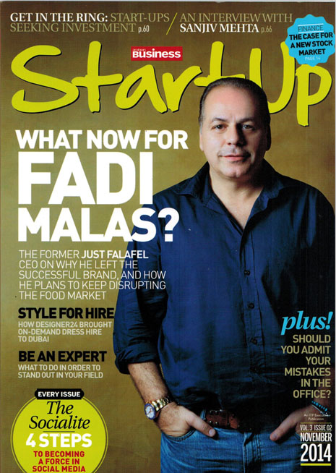

The above are the 4 publication in Dubai focused on SMEs.

**SME Advisor ME**

SME Advisor ME is the oldest magazine, published by CPI, Dubai. I was the Sales Director for SME Advisor ME from 2007-2009. With a mere US$ 4000 per month sales revenue in 2007, I took this publication to US$ 45,000 per month sales only on adverts alone. Also launched the SME Awards and few other campaigns successfully. Now the magazine is doing fairly well. It’s a home grown title.

***Strengths*:**

**→** *Part of a well-established Media group with diverse publications that supports SME Advisor*

*ME magazine.*

**→** *Been in the market for nearly 8 years now.*

***→*** *They have managed to grab few big names to have a contractual advertisement deal on a*

*yearly basis.*

***Weakness***:

**→** Controlled circulation to 2000+ SMEs in Dubai only. Few in Abu Dhabi.

**→** Not sold through news stands

**→** Only few events – once a year, mainly the SME Awards function.

**→** No specific editorial theme every month

**→** No penetration in other GCC markets

**→** Contents mostly related to IT and few start up stories

**→** Published only in English language

**Intelligent SME**

Part of SPI Group, based in Dubai. Publication in market since 2009.

***Strengths*:**

**→** Managed to get DU as one of their main sponsors for magazine

**→** Does an annual 3 day Event named “SME World Summit” in Dubai

***Weakness***:

**→** Local magazine with controlled circulation

**→** No penetration in other GCC markets or other emirates apart from Central Dubai

**→** Not sold through news stands

**→ E**vents – once a year, mainly the SME World Summit.

**→** No specific editorial theme every month

**→**Poor Content

**→** Poor design and layout used in the magazine

**→** Published only in English language

**Start-Up Magazine**

Part of ITP Group. Launched in 2012. Local title.

***Strengths*:**

**→** Part of an established Media house in Dubai – ITP

**→** Available at select outlets and newsstands in Dubai

**→** Fairly good content.

→ Being a part of ITP, it enjoys group advert deals booked for all other magazines at ITP

***Weakness***:

**→** Very Dubai focused

**→** No penetration in other GCC markets

**→** No events to complement the magazine

**→** Magazine size is only A5, looks like a catalogue.

**→** No specific editorial theme every month

**→** Published only in English language

**Entrepreneur ME Magazine**

Part of BNC Publishing. Started by a group of people who were working with ITP earlier. Entrepreneur ME is licensed publication from Entrepreneur US. Launched in 2013 in Dubai.

***Strengths*:**

**→** Part of Entrepreneur US, a well acclaimed publication

**→** Good contents

**→** Sold through News Stands

**→** Published in both Arabic & English

**→** Good design and layout

***Weakness***:

**→** Very Dubai focused

**→** ConductedOnly one Event mainly based on IT

**→** Pays a huge royalty to Entrepreneur US for the publishing license in Middle East

**→** No penetration in other GCC markets

**→** No specific editorial theme every month

Organisational chart

|  |  |  |  |  |  |  |  |  |  |  |  |  |  |  |  |
| --- | --- | --- | --- | --- | --- | --- | --- | --- | --- | --- | --- | --- | --- | --- | --- |
|  |  |  |  |  |  |  | **Board of Director** | |  |  |  |  |  |  |  |
|  |  |  |  |  |  |  |  |  |  |  |  |  |  |  |  |
|  |  |  |  |  |  |  |  |  |  |  |  |  |  |  |  |
|  |  |  |  |  |  |  | **MD & CEO** | |  |  |  |  |  |  |  |
|  |  |  |  |  |  |  |  |  |  |  |  |  |  |
|  |  |  |  |  |  |  |  |  |  |  |  |  |  |  |  |
|  |  |  |  |  |  |  |  |  |  |  |  |  |  |  |  |
|  |  |  |  |  |  |  | **Director - Ops** | |  |  |  |  |  |  |  |
|  |  |  |  |  |  |  |  |  |  |  |  |  |  |
|  |  |  |  |  |  |  |  |  |  |  |  |  |  |  |  |
|  |  |  |  |  |  |  |  |  |  |  |  |  |  |  |  |
|  | **Online / IT Dept** | |  | **Sales Dept** | |  | **Editor** | |  | **Events Team** | |  | **Finance** | |  |
|  |  |  |  |  |  |
|  |  |  |  |  |  |  |  |  |  |  |  |  |  |  |  |
|  |  |  |  |  |  |  |  |  |  |  |  |  |  |  |  |
|  |  |  |  |  |  |  | **Freelance Journalists** | |  |  |  |  |  |  |  |
|  |  |  |  |  |  |  |  |  |  |  |  |  |  |
|  |  |  |  |  |  |  |  |  |  |  |  |  |  |  |  |

Management Profile

**Dojo Jose**

A seasoned sales and marketing professional with more than 20 years of experience, Dojo Jose has a long history of working with reputed firms in the publishing and printing firms both in the UAE as well as India. For the past six years, he has also been a successful entrepreneur and has helped establish Aspire Media Pvt Ltd and the flagship portal for SMEs ww.SmallEnterPriseIndia.com , Bangalore and Aspire Events as a strategic B2B event organizing company in the ME region. He has earned his MBA from Bangalore University specialised in marketing.

Has worked previously with Corporate Publishing International (CPI), IDGs Middle East partner as Sales Director for SMB Advisor ME (a magazine for the Small & Medium Business in the Middle East) where he achieved considerable success in re-launching and re-positioning the title. He helped conceive events as well as several innovative campaigns to increase revenue opportunities for the magazine. The pinnacle of these initiatives was the SMB Business awards in Nov’08 which was among the first such initiatives for a magazine tracking the SMB space in the Middle East region.

Prior to his stint with CPI, he served as Sales Manager for over 6 years at Dabbagh Information Technology (DIT), in Dubai where he had considerable success as part of the core sales team, selling across several leading IT and B2B titles including PC Magazine ME (English & Arabic Editions) , Arabian Reseller News, Forbes Arabia, PlayStation ME magazine and several other special projects and titles.

One of his strengths has been the will to work harder and meticulously even in tougher territories as well helping establish new markets for the several print titles he has worked on. This was never so much in evidence as during his inning with Al Ghurair Printing & Publishing Co. LLC, when he helped develop new markets overseas for print sales like Nairobi, Zimbabwe, South Africa, Tanzania, Uganda, Mozambique and European countries. The Direct mail campaign that he introduced in early 1999 made a huge success to Middle East, Africa & UK. Introduced the concept of “ Total Print Management Solution” acceptable to the corporate and publishing houses in UAE and Africa. Arranged many sponsored business meetings throughout Europe and Africa and achieved considerable print market share. During the earlier part of his career, he has also worked with Tata Yellow Pages (formerly

known as Tata Donnelley Ltd / Tata Press Ltd) in India. He joined its Bangalore office in 1993 December. He was awarded the topper in Bangalore office and was promoted as Territory Manager and transferred to head Coimbatore branch.

Now in his new role as MD & CEO for Aspire Media Pvt Ltd, Bangalore, Dojo is carving a strong niche for the company as a proven publisher for Small Business Entrepreneurs in India. The company has successfully organised unique format events called SME Learning Series in 2011 , a successful road show through 10 cities in India. Many other B2B events for small business planned are SMB Business Makeover, Hospitality ICT Summit, GCC SME Summit, Print Buyers Summit, PetroICT Summit, Digital Print & Imaging Summit, Healthcare ICT Summit and Franchise Summit ME.

**V. Pradeep Kumar**

**Author and Senior Management Professional**

V.Pradeep Kumar is a publishing and media expert, with diverse local and international experience.

Mr Kumar holds an MBA [1980] and has strong cross functional knowledge and skills, both strategic and hands on leadership, experience of both start up and established operations, with balance of people and task orientation.

After starting the southern operations of Tata Infomedia Ltd, as General Manager [south], in 1993, Mr. Kumar is credited with the successful launch of Tata Press Yellow Pages in southern India. He was part of senior management responsible for diversification of the company into several B2B and B2C magazines such as Overdrive, Better Photography, AV Max, Search and so on.

From 2003 till 2009, Mr. Kumar headed Hawk Media LLC, Dubai, UAE and was responsible for the resurrection of the brand, ‘Hawk’.

After 30 years of distinguished corporate experience, he is now based at Bangalore focusing on management consultancy and training services.

Mr. Kumar is also a prominent writer on leadership, management, economy and education. His first book, ‘Simple is difficult’ was published in 2009 and he is currently working on several new book projects.

**Vinil Ramdev – Chief Editor**

Born in Bangalore, India and lived in Bangalore most of his life. In 2001, he went to the United States and got a Bachelor’s degree in Marketing from Florida Atlantic University in Boca Raton, Florida in 2004.

In 2004, he started 2 internet related businesses with very little to no money. I have exited both these businesses. In 2006, he started a retail business in India, built the business and sold the business in early 2009.

Thereafter, in April of 2009 he decided to move temporarily to Mumbai and I started a consulting business where his services included preparing business plans, sales training, setting up turn key businesses, helping in financing, writing content and sales copy mostly copy writing and a few other related services. He did experiment with many of these services.

While doing consulting he realized lot of entrepreneurs required training along with the consulting part. He truly believe when your business isn’t growing beyond a certain stage then it’s probably because the entrepreneur isn’t growing as well. It’s very critical that the entrepreneur is learning something new everyday and growing if he wants his business to grow.

**Dr. K.J.John ( Retd. Prof. NIT Calicut *(formely known as REC (Regional Enginerring College)***

Group Director, Prof.K.J.John is senior consultant in the Chemical business industry. He holds a PhD in Polymer Science, from IIT Kharagpur. He was a senior faculty at NIT Calicut ( former Regional Engineering College – REC). He was the head of Applied Science Dept at REC. After a long service of more than 4 decades at REC, Prof K.J John is now retired and serves the Chemical industry as a consultant.

Events Plan



Social Media

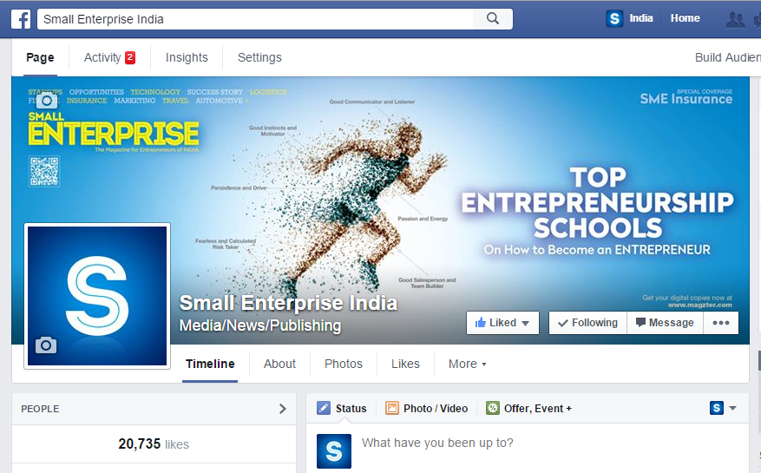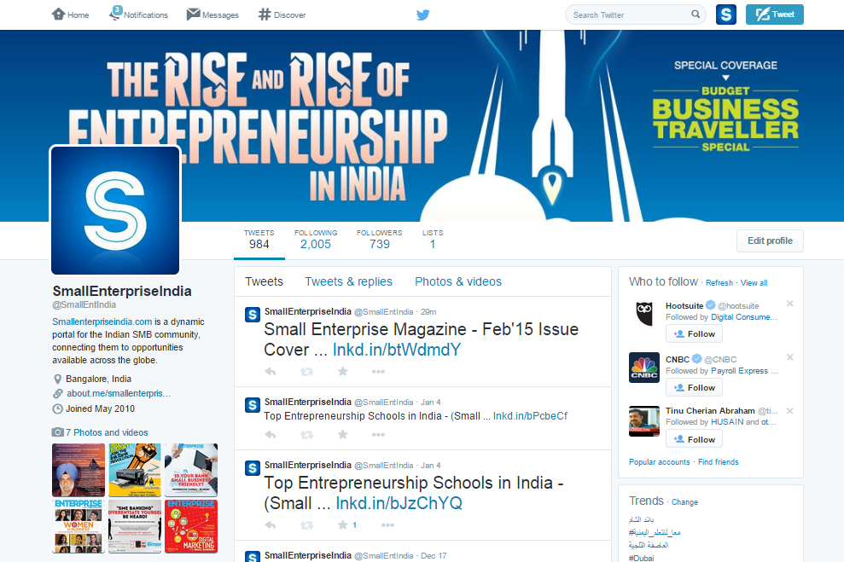

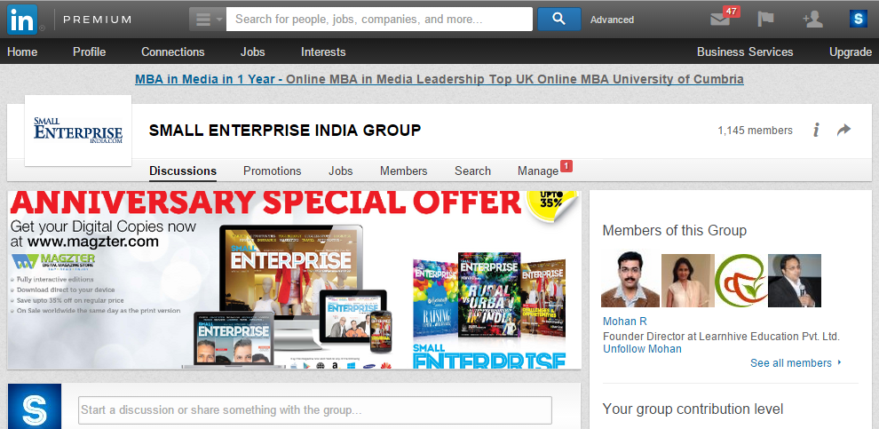

Financial Plan

|  |  |  |  |  |  |  |
| --- | --- | --- | --- | --- | --- | --- |
| ***Forecasted Statement of Comprehensive Income (AED)*** | | | | | | |
|  |  | **2015** | **2016** | **2017** | **2018** | **2019** |
| **Income** | **Sch No:** | **Total** | **Total** | **Total** | **Total** | **Total** |
|  |  |  |  |  |  |  |
| **Revenue** |  | 742,061 | 2,191,306 | 2,857,484 | 3,836,526 | 4,410,386 |
| **Cost Of revenue** |  | (167,572) | (443,336) | (681,233) | (803,583) | (956,879) |
|  |  |  |  |  |  |  |
| ***Expected Gross Profit*** |  | **574,489** | **1,747,970** | **2,176,251** | **3,032,943** | **3,453,507** |
|  |  |  |  |  |  |  |
| **Other Income** |  | 0 | 0 | 0 | 0 | 0 |
| **General and admin expenses** |  | (1,156,137) | (1,812,272) | (2,160,322) | (2,242,908) | (2,553,037) |
| **Selling and distribution expenses** |  | (18,350) | (31,195) | (36,700) | (36,700) | (55,050) |
| **Finance chatges** |  | (4,771) | (4,771) | (6,239) | (7,340) | (7,340) |
|  |  |  |  |  |  |  |
|  |  |  |  |  |  |  |
| **Expected Profit/(Loss ) for the year** |  | **(604,769)** | **(100,268)** | **(27,010)** | **745,995** | **838,079** |

|  |  |  |  |  |  |
| --- | --- | --- | --- | --- | --- |
| **REVENUE SUMMARY (AED)** | **Yr 1 (2015)** | **Yr 2 (2016)** | **Yr 3 (2017)** | **Yr 4 (2018)** | **Yr 5 (2019)** |
| **Advert Sales ( Print & Online)** | 306,235 | 1,045,950 | 1,546,905 | 1,890,050 | 2,161,630 |
| **Subs/Stand Sales** | 6,771 | 23,011 | 36,994 | 43,306 | 46,756 |
| Online Ad Sales | 20,185 | 84,410 | 91,750 | 106,430 | 124,780 |
| **Events** | 386,850 | 981,050 | 1,106,600 | 1,716,000 | 1,981,800 |
| SEI Business Club | 22,020 | 56,885 | 75,235 | 80,740 | 95,420 |
|  |  |  |  |  |  |
| **Total Revenue (Income)** | **742,061** | **2,191,306** | **2,857,484** | **3,836,526** | **4,410,386** |

Exit Plan

|  |  |  |  |  |  |  |  |  |  |
| --- | --- | --- | --- | --- | --- | --- | --- | --- | --- |
| ***Exit Plan – 7 Years*** | | | | | | | | | |
| ***Required Investment*** | ***Pay Back Schedule*** | ***2015*** | ***2016*** | ***2017*** | ***2018*** | ***2019*** | ***2020*** | ***2021*** | ***Total Pay Back*** |
| ***AED 2.5 Million*** | ***Interest %*** | *0* | *0* | *10%* | *12%* | *12%* | *15%* | *15%* | *1,600,000* |
|  | *0* | *0* | *250,000* | *300,000* | *300,000* | *375,000* | *375,000* |
| ***Principal Amount*** | *0* | *0* | *0* | *300,000* | *500,000* | *500,000* | *1,200,000* | *2,500,000* |
| ***Total Pay Back Amount*** | | *0* | *0* | *250,000* | *600,000* | *800,000* | *875,000* | *1,575,000* | ***4,100,000*** |

----------------------- 000 ------------------------